**HTTP + JSON + HTML + Email + PDF from HTML**

[ISBN:9780789748591](https://www.googleapis.com/books/v1/volumes?q=ISBN:9780789748591)

<https://www.googleapis.com/books/v1/volumes?q=>

Steps to follow:

1. Create an Instant flow as trigger
2. Add input text column to get the ISBN number as user input

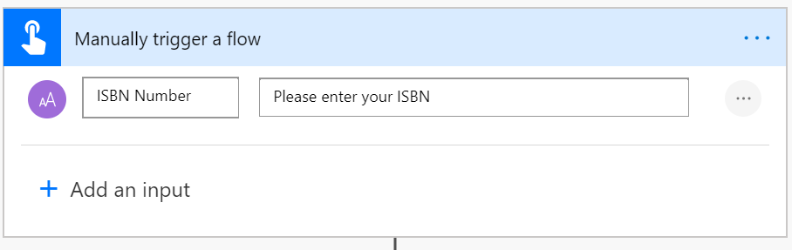

1. Add an action HTTP
2. Enter Method = Get and URI = url of the rest api and pass the input parameter
3. If required add the Headers and body content based on your REST API

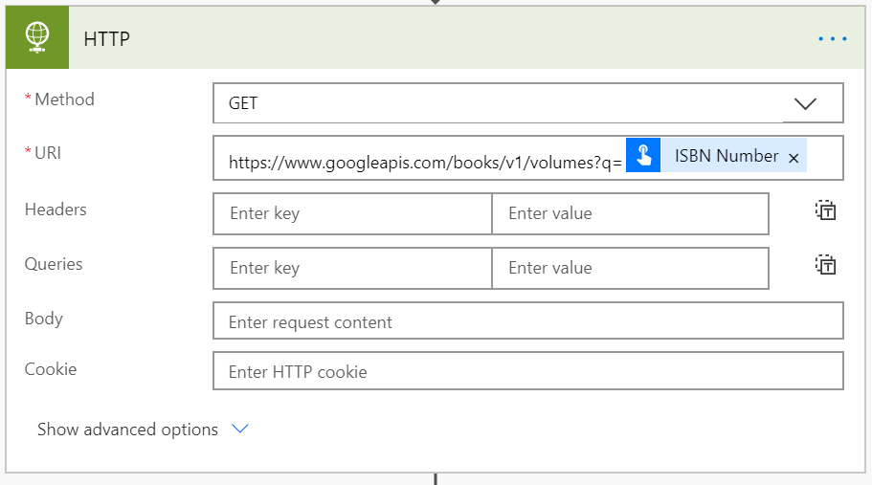

1. Add another action Parse JSON to handle the response object
2. Click Generate from sample button and add the any output from your rest api to create schema.

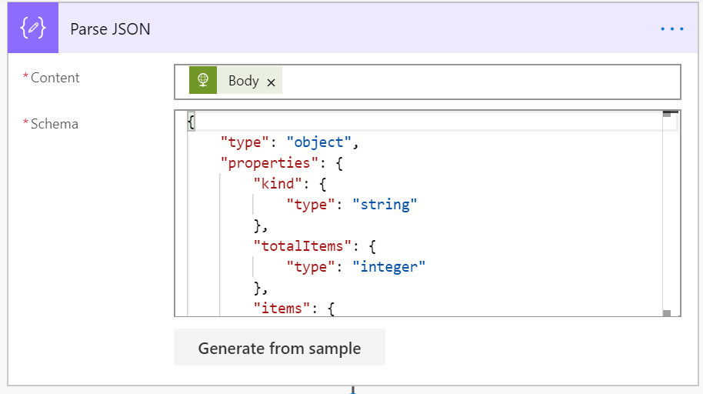

1. Add another action to convert the items as HTML
2. Select columns as custom and Add header and value from dynamic content

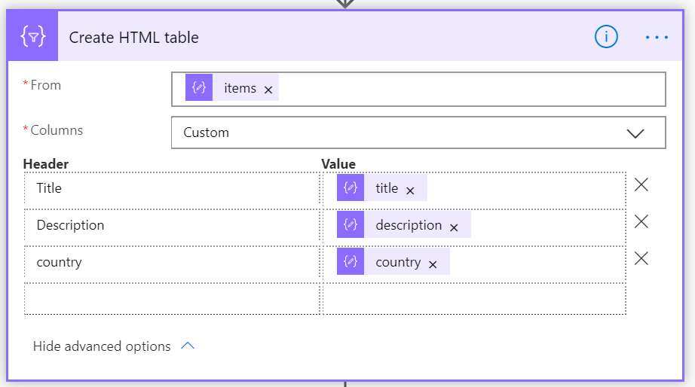

1. Add another action the Muhimbi “**Convert HTML to PDF**” action to the Flow Canvas
   1. Create the account before using
   2. This is free for small Projects
2. Set the HTML output as source

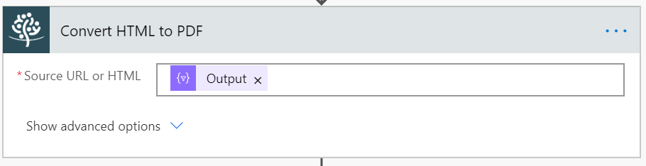

1. Add another action to send email
2. Give the attachment name
3. Select the attachment content as Processed file content

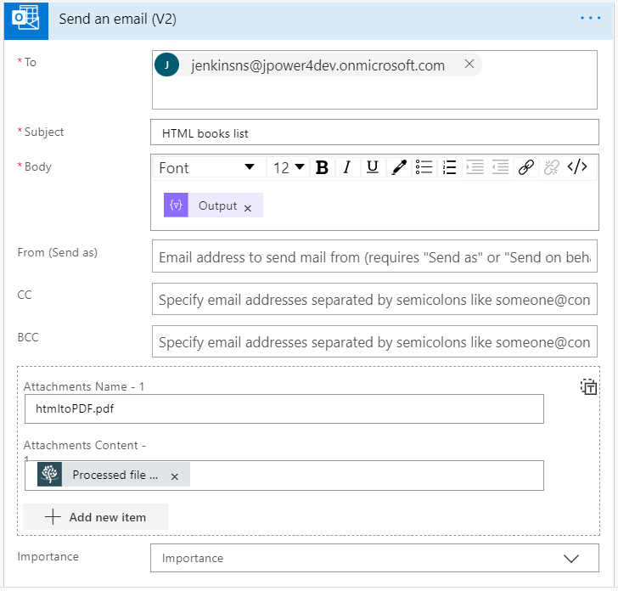

1. Save and test the flow
2. If it throws any pdf conversion error

**Follow the fix**

* There is an easy fix for this.
* Export your flow.
* Import your flow (as a new flow).
* Now the new flow will work.
* this problem happens sometimes when you introduce new connectors to a flow after you have initially saved the flow without using that connector.